PLAINFIELD BOARD OF EDUCATION
FREDERIC W. COOK K-7 CENTER
September 2016
DISTRICT WEBSITE: www.plainfieldnjk12.org
Sun | MONDAY | TUESDAY | WEDNESDAY | THURSDAY | FRIDAY | Sat
 |  |  |  | 1 | 2 | 3
4 | 5 | 6 | 7 | Back to school Assembly  1:00 pm | 9  Lion King Cast  Plainfield City Hall  8:30-10:30am | 10
11 | 12 | 13 | 14 | 15 | 16  Constitution Center, PA  4/5 Grades  6:00am-5:30pm  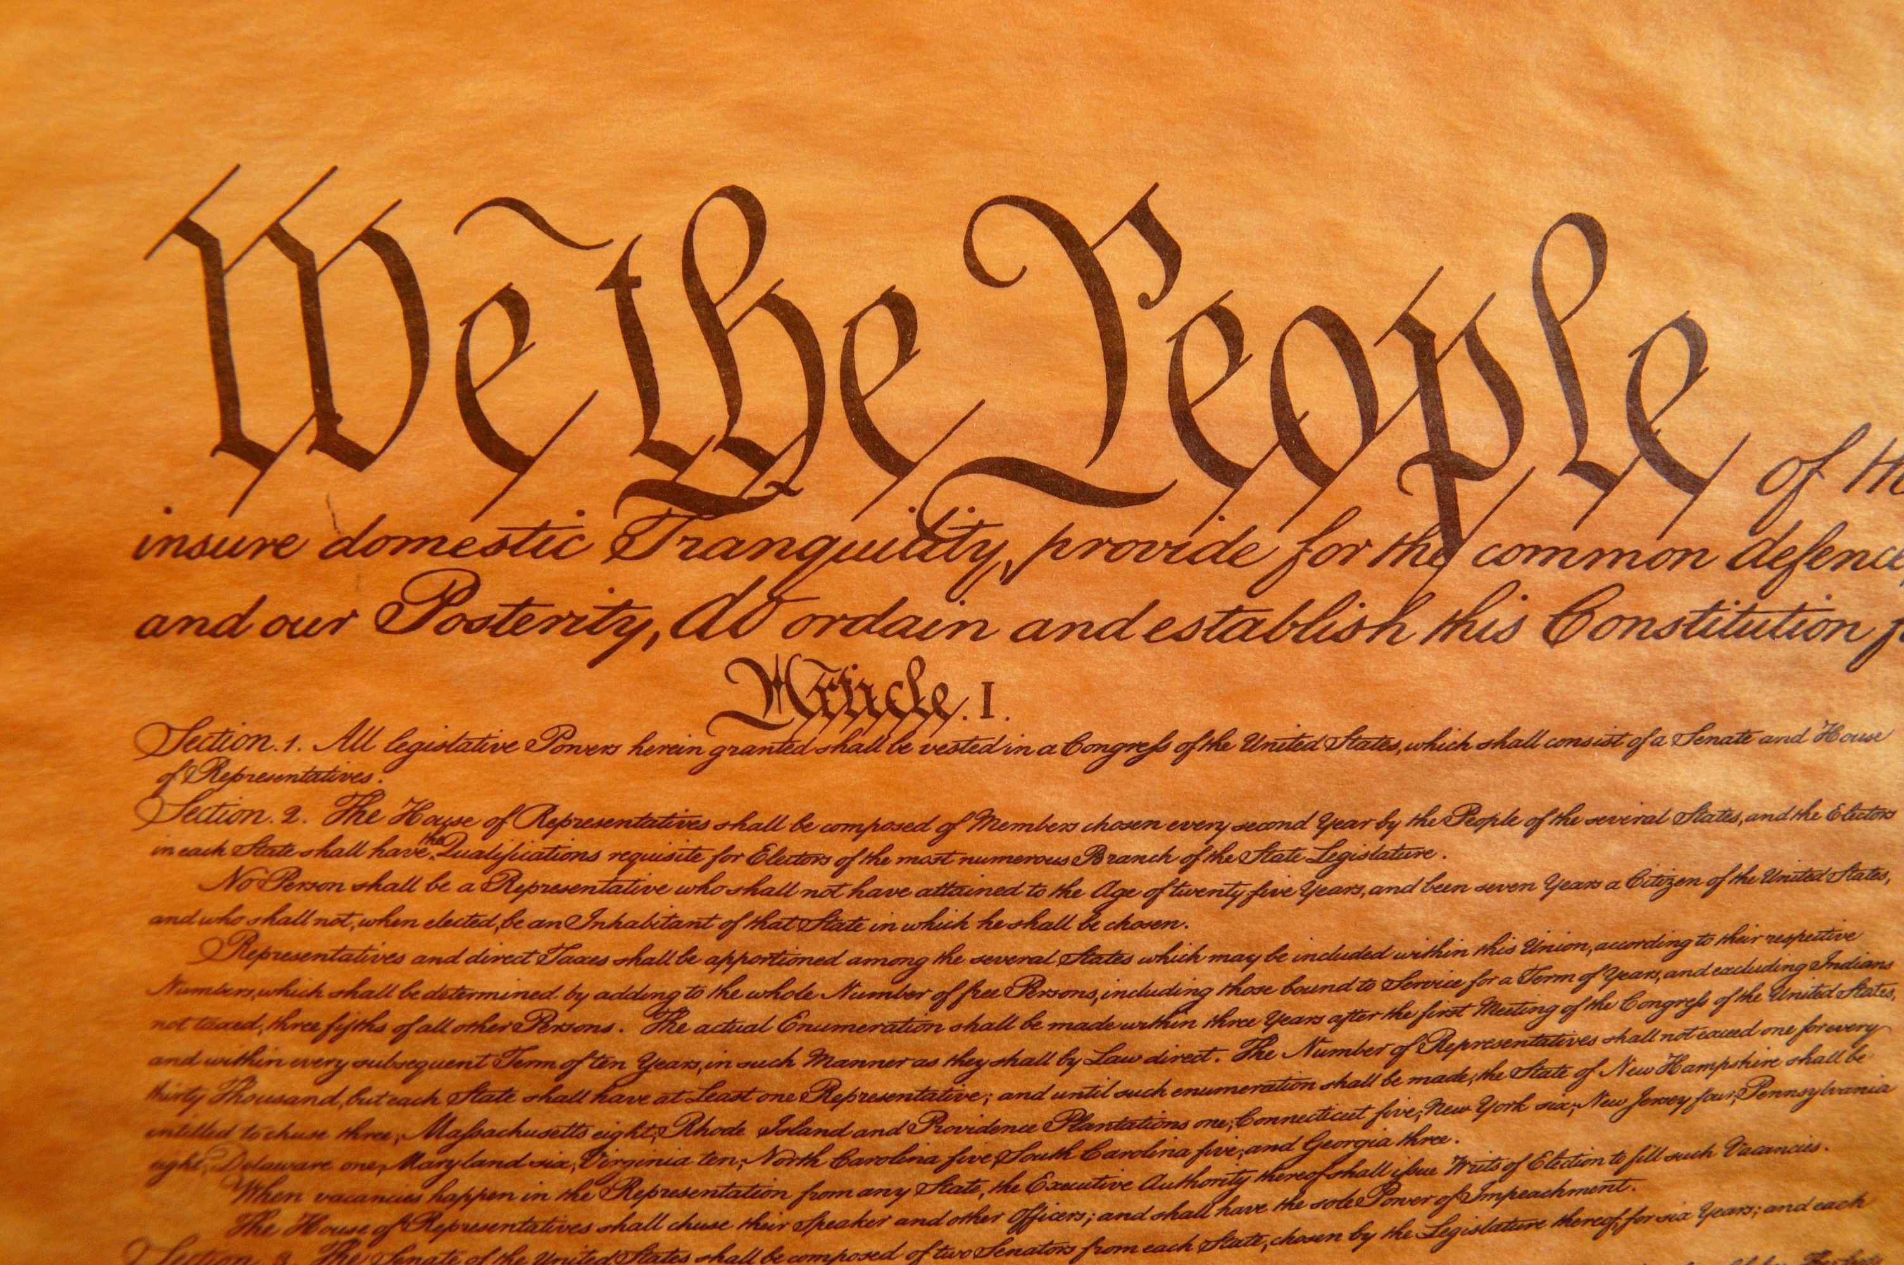 | 17
18 | 19  Constitution Assembly  1:00pm  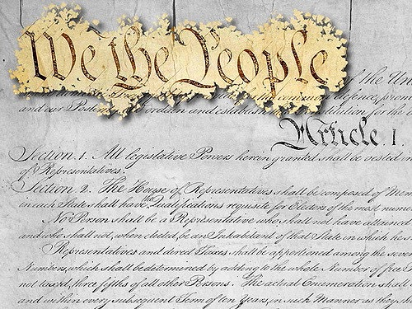 | 20 | 21 | 22  Plainfield Tours 8:3012:00pm  3rd grade  Mrs. Barret/Mrs. Harris | 23 | 24 | 25
25 | 26 | 27  Recycling Assembly 10:00am | 28  Back to School Night  6:30am | 29 | 30

Up Coming Events
Hispanic Heritage Assembly/Lunch Friday, October 14th
Walk-A-Thon Friday, October 21st/Rain Date Friday, October 28th
Math/Science Night Thursday, October 27th
Half Day Dismissal 12:10pm!! Professional Development October 7th
Columbus Day Schools & Offices Closed!! Monday, October 10th

